From: Austin-Bergstrom International Airport- 3600 Presidential Boulevard, Austin, Texas‎
To: (SAG) San Antonio Parking Garage- 2420 San Antonio St, Austin, TX 78705‎
- Head east toward Presidential Blvd, go 0.3 mi
- Continue straight onto Presidential Blvd, go 0.2 mi
- Slight right to stay on Presidential Blvd, go 0.5 mi
- Turn left onto E State Hwy 71 Service Rd, go 0.2 mi
- Take the ramp on the left onto TX-71 W, go 5.1 mi
- Take the exit onto I-35 N/US-290 E toward Waco, go 5.0 mi
- Take exit 235B on the left toward Manor Road, go 0.2 mi
- Keep right at the fork, follow signs for Manor Rd and merge onto I-35 Frontage Rd, go 0.4 mi
- Slight right onto the ramp to Lyndon B. Johnson Library/Dean Keeton, go 0.1 mi
- Sharp right onto E Dean Keeton St, go 1.1 mi
- Turn left onto Guadalupe St, go 0.1 mi
- Take the 2nd right onto W 24th St, go 246 ft
- Take the 1st right onto San Antonio St where parking is found, Destination will be on the left, Total 13.4 mi
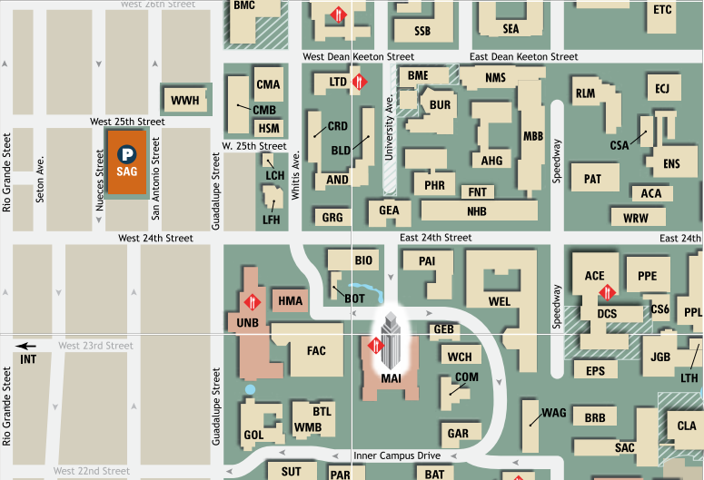

From SAG, walk south toward W. 24th street. Turn left on W 24th. and cross over Guadalupe, continuing straight until you see PAI on your right. Our office is room 5.03, located on the 5th floor.

