Polymaths in the News:
Oliver Sacks, 1933-2015
Every week, we post a story about a public figure who's been described as a polymath. This week's story concerns the passing of one of the world's best-known neurologists, and one of its most captivating writers.
August 31, 2015
"Dr. Sacks . . . was a polymath and an ardent humanist..." - Michiko Kakutani, The New York Times, August 30, 2015
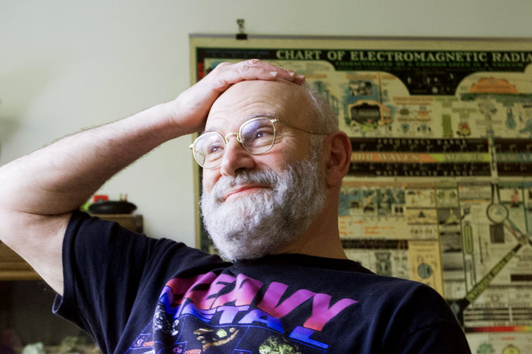
Oliver Sacks, neurologist and best-selling author of Awakenings and The Man Who Mistook His Wife For a Hat, died this past Sunday at his home in Manhattan. His assistant attributed the cause to cancer. He was 82.
In her remembrance one day later in The New York Times, Michiko Kakutani wrote that, "whether he was writing about his patients, or his love of chemistry or the power of music, he leapfrogged among disciplines, shedding light on the strange and wonderful interconnectedness of life — the connections between science and art, physiology and psychology, the beauty and economy of the natural world and the magic of the human imagination."
Dr. Sacks was a practicing doctor and a professor of neurology at the New York University School of Medicine whose best-known writings were empathetic and penetrating case histories of patients with highly unusual neurological conditions. Kakutani writes that he lived life as an adventure, going from medical school to a period working as a forest firefighter, holding at one time a weight-lifting record in California, and sometimes driving hundreds of miles on his motorcycle on weekends.

